PRAKTIKUM BASIS DATA

MODUL
02_DDL_DML


Oleh:

Haryanto Wifakul Azmi 103122400037

PROGRAM STUDI S1 REKAYASA PERANGKAT LUNAK
DIREKTORAT KAMPUS PURWOKERTO
UNIVERSITAS TELKOM
2026
JURNAL/TP

- Soal 1
Jawaban:
        - Table film
Source code :
create table film ( id_film int primary key,judul varchar(100),sinopsis varchar(300),tahun int,durasi int);
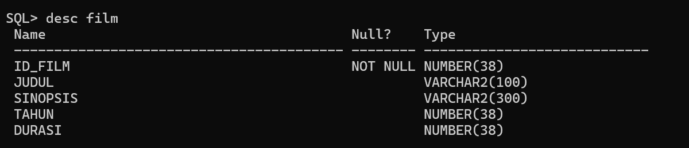
        - Table Theater
Source code:
create table theater(id_theater int primary key,harga int,kapasitas int,kelas varchar(10));
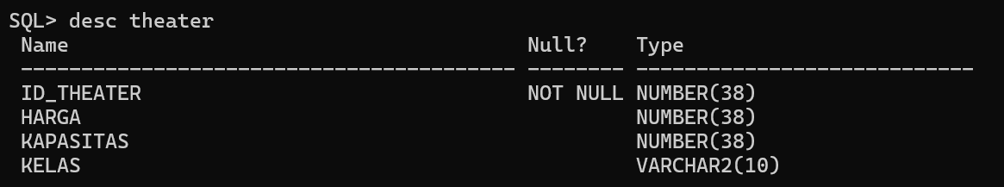
        - Table Member
Source code:
create table member(id_member int primary key,nama varchar(50),no_hp int,tgl_lahir date,email varchar(50));
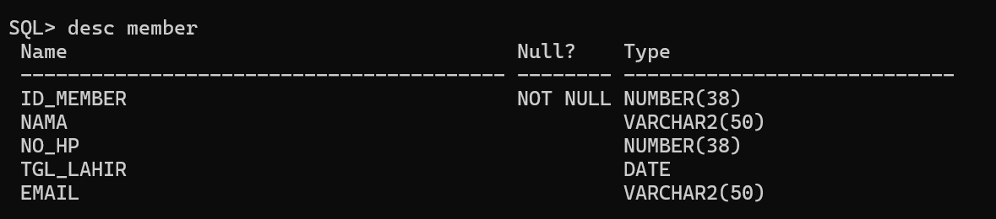
        - Table Jadwal
Source code:
create table jadwal(id_jadwal int primary key,periode_start date,periode_end date,id_film int,id_theater int,foreign key (id_film) references film(id_film),foreign key (ID_THEATER) references theater(ID_THEATER));
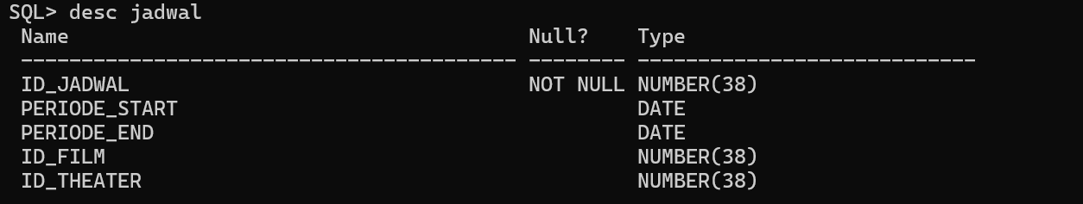
        - Tabel iventaris
Source code:
create table inventaris(id_inventaris int primary key,nomor_kursi varchar(10),id_theater int,foreign key (id_theater) references theater(id_theater) );
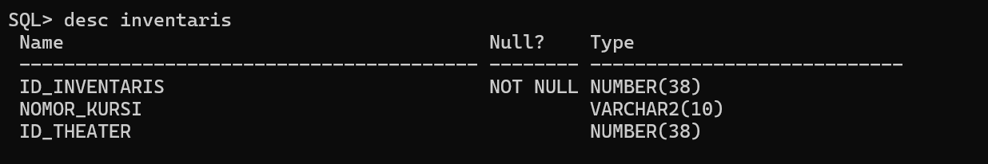
        - Tabel Transaksi
Source Code:
create table transaksi(kode_pemesanan int primary key,status varchar(50),tanggal date,total_harga int,id_jadwal int,id_member int, foreign key (id_jadwal) references jadwal(id_jadwal),foreign key (id_member) references member(id_member) );
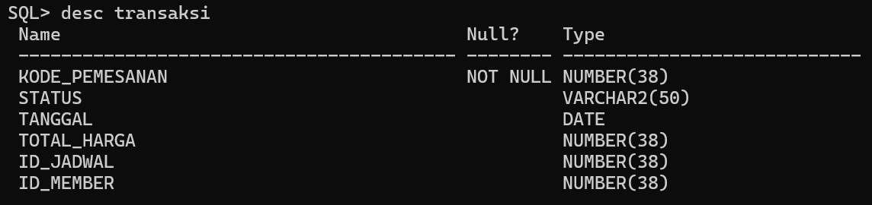
- Soal 2
  - Film
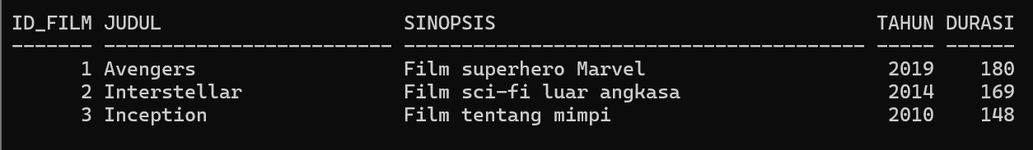
  - Theater
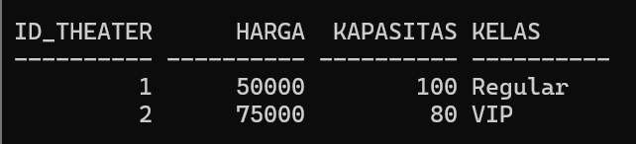
  - Member
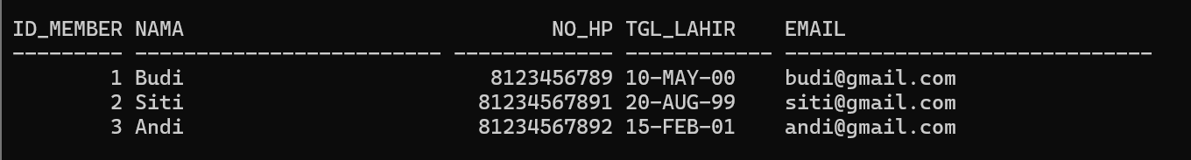
  - Jadwal
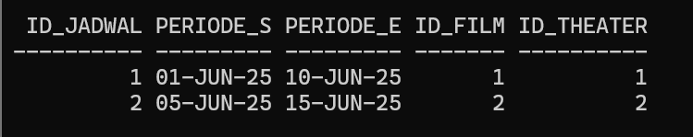
  - Inventaris
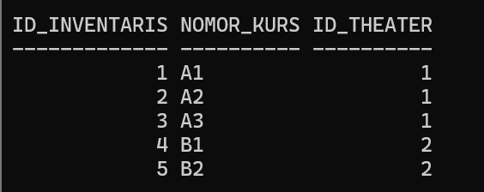
  - Transaksi
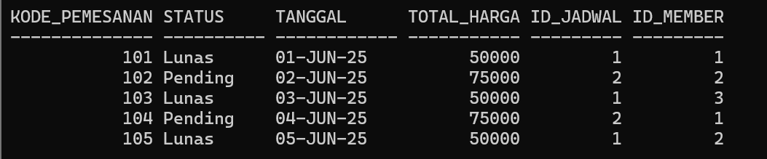

- Soal 3
update transaksi set status = 'lunas' where kode_pemesanan = 102;
update transaksi set status = 'cancel' where kode_pemesanan = 104;
update transaksi set total_harga = '85000' where kode_pemesanan = 101;
update transaksi set total_harga = '60000' where kode_pemesanan = 105;
update transaksi SET tanggal = TO_DATE('06-JUN-2025','DD-MON-YYYY');

before


After
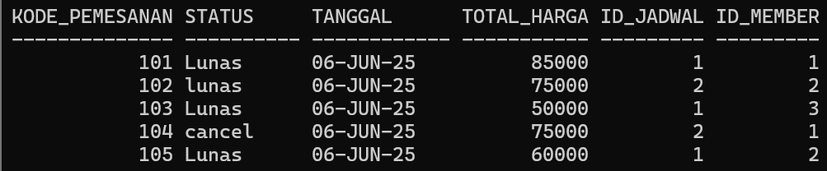
- Soal 4
delete from transaksi where status = 'cancel';
delete from transaksi where total_harga = '50000';

before


After
